**Parkridge Elementary**

**Kindergarten Suggested Supply List**

**2024-2025**

**Please label these items with your child’s name:**

* Backpack (no wheels, & big enough to hold a folder)
* Reusable water bottle (pop-up lids are best)
* 1 pair of **Fiskars** blunt-tip scissors
* Headphones (please make sure they are over-the-ear with a jack that goes into the computer; no rechargeable, no Bluetooth, no earbuds—thank you)

*Please do not purchase a supply box, pencils, folders, or crayons as the school will provide these items for each student.*

**Any of the following donations are also welcome! Please do not label these items with your child’s name as they will be placed in a class stockpile for all students to share throughout the year. Thank you!**

* **Elmer**’s purple or white glue sticks (no clear)
* 1 - 2 Highlighters (yellow only)
* 1 - 2 Chisel-point dry-erase markers (black only)
* 1 – 2 Fine-point dry erase markers (black only)
* Zipper bags (snack, sandwich, quart, & gallon)
* 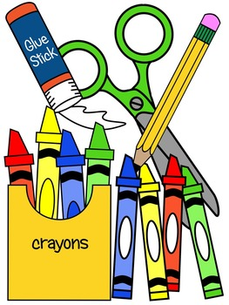1 box **Crayola** markers
* Disinfectant wipes
* Box of tissue
* Hand sanitizer (with pump)
* 5 oz. cans of **Play-Doh**
* Colored copy paper
* White cardstock

**\*Please bring supplies when attending Meet the Teacher\***